Supplementary Material 2. HROC for FFR of 0.75 and 0.8 at the vessel level.
Figure S.1a. HROC for FFR of 0.75 at the vessel level
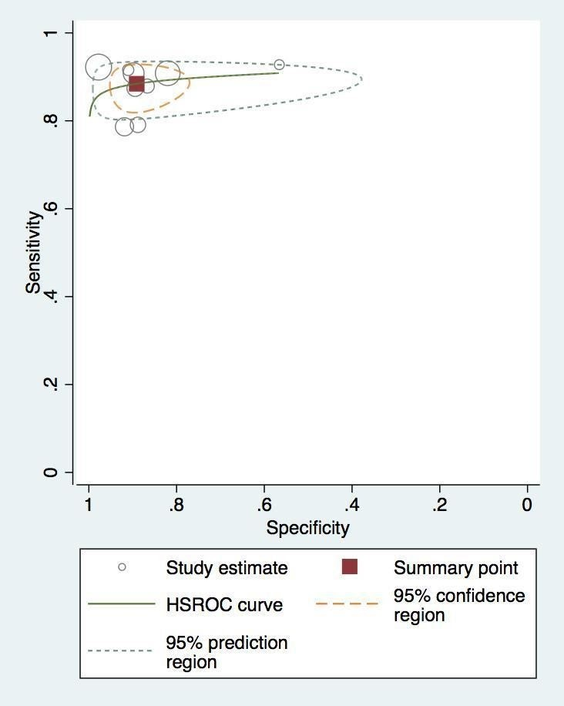
Figure S.1b. HROC for FFR of 0.8 at the vessel level
