Supplementary Material 3. HROC for FFR of 0.75 and 0.8 at the patient level.
Figure S.2a. HROC for FFR of 0.75 at the patient level
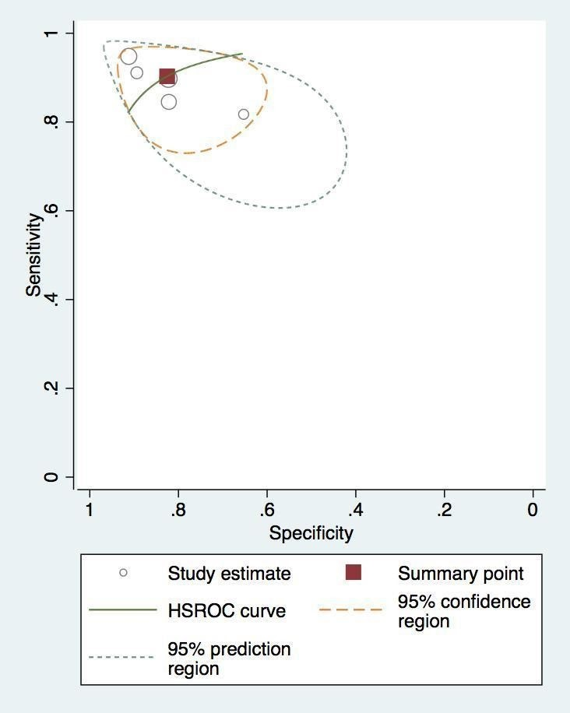
Figure S.2b. HROC for FFR of 0.8 at the patient level
