Supplementary Material 4. HROC for CMR at vessel level at spatial resolution of 1.5T and 3T.
Figure S.3a. HROC for CMR at vessel level at spatial resolution of 1.5T.
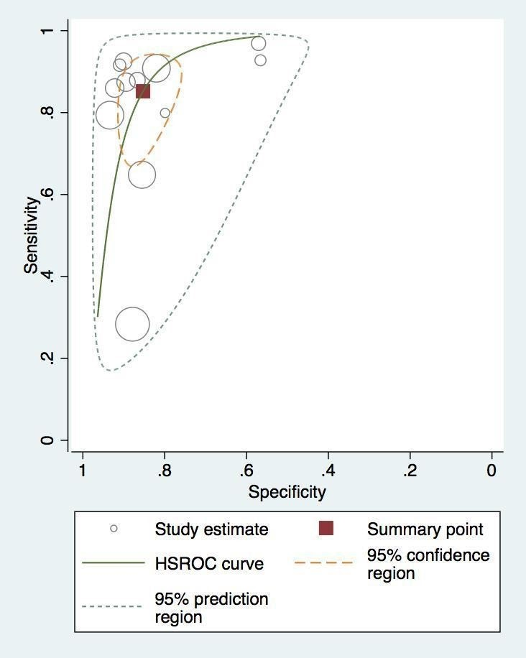
Figure S.3b. HROC for CMR at vessel level at spatial resolution of 3T.
