Supplementary Material 6. Meta-regression based on the prevalence of MI < 60% at the patient level, MI > 60% at the vessel level, and MI < 60% at the vessel level.
Figure S.5a: Meta-regression based on the prevalence of MI <60% at the patient level
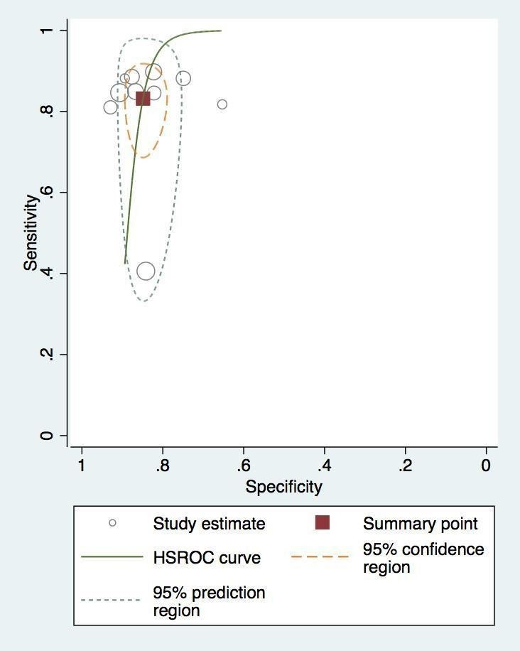
Figure S.5b: Meta-regression based on the prevalence of MI >60% at the vessel level
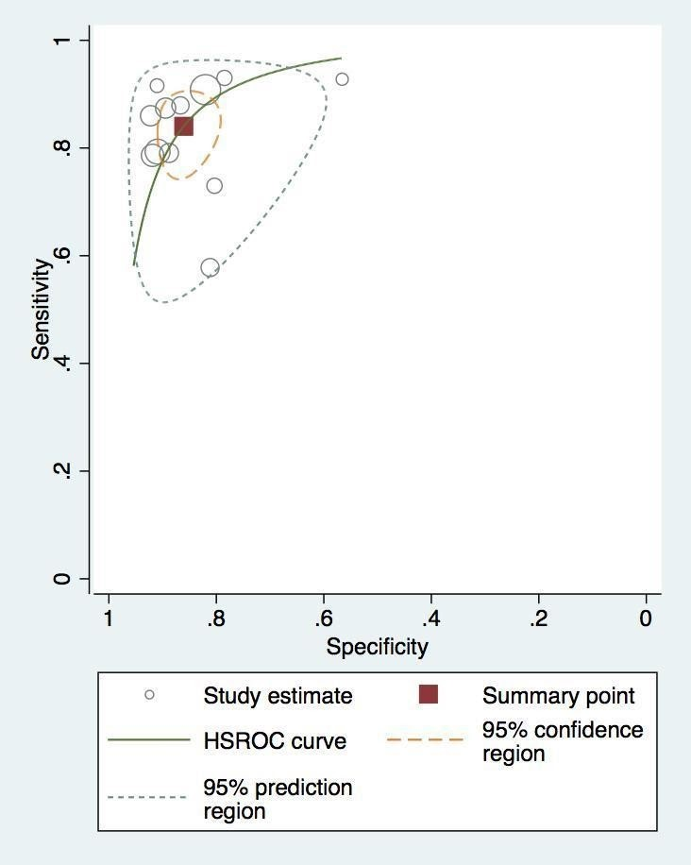

Figure S.5c: Meta-regression based on the prevalence of MI <60% at the vessel level
