Supplementary Material 7. Meta-regression based on the age < 65 at the patient level, < 65 at the patient level, and > 65 at the vessel level.
Figure S.6a: Meta-regression based on the age <65 at the patient level
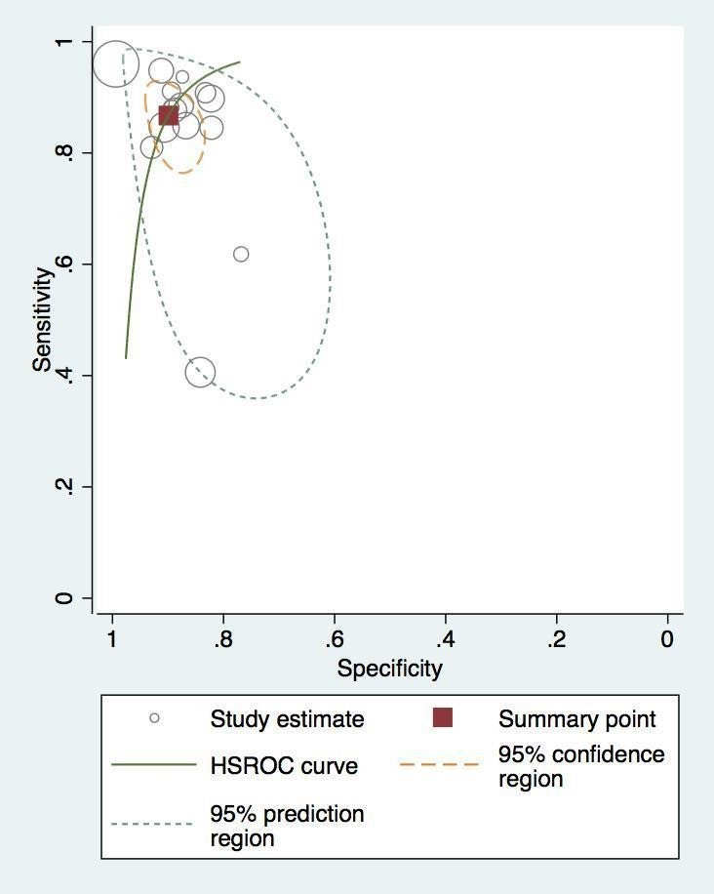
Figure S.6b: Meta-regression based on the age <65 at the patient level
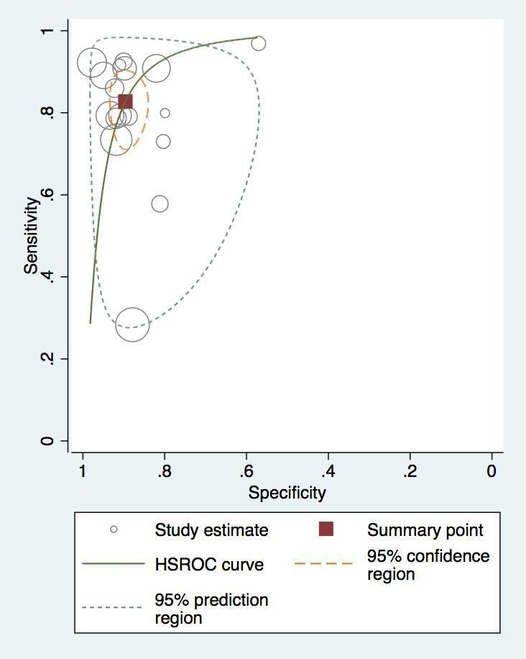
Figure S.6c. Meta-regression based on the age >65 at the vessel-level
