APPENDIX I

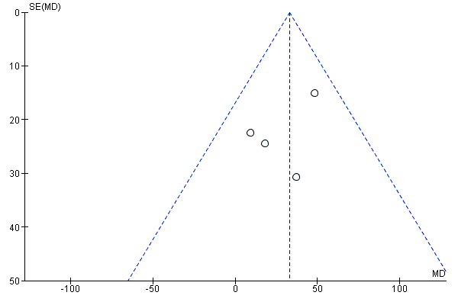
- Funnel plot of the included studies showing no evidence of publication bias. Lower standard errors indicate better precision and larger study size.

