Bivalirudin versus Heparin During PCI in
Patients with Acute Myocardial Infarction

Authors: Hiten Patel, Rana Garris, Suchit Bhutani, Priyank Shah, Upamanyu Rampal, Rahul Vasudev, Rajkumar Doshi, Gabriel Melki, Hartaj Virk, Mahesh Bikkina, Fayez Shamoon

Trial names as previously outlined in manuscript, Table 1.

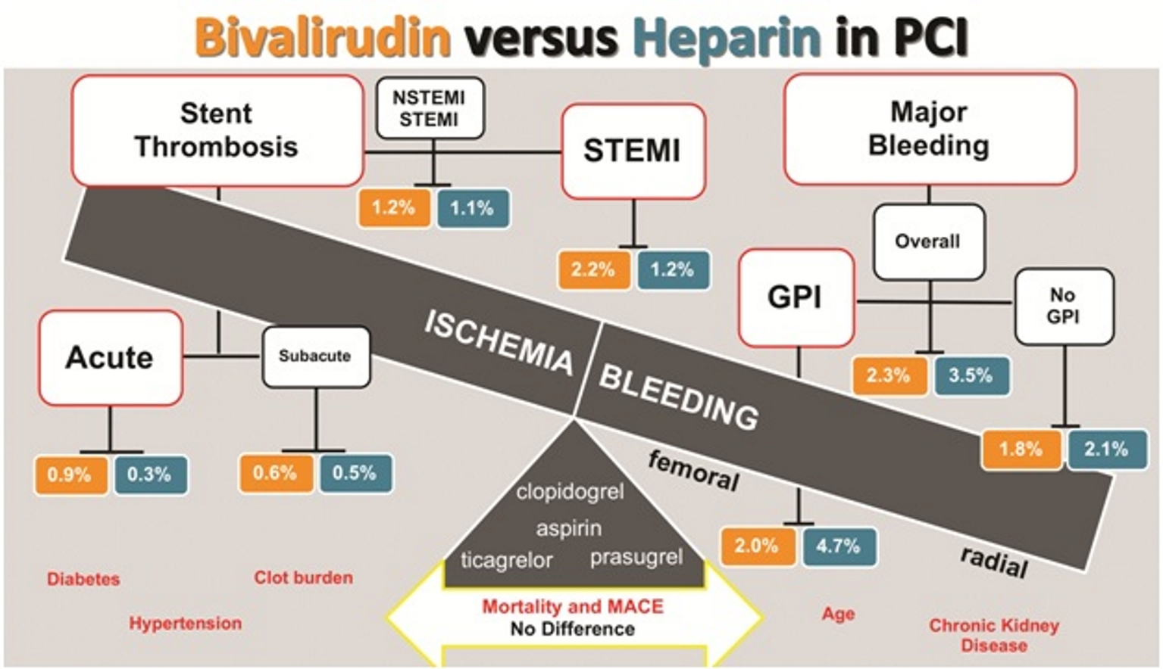

Central Figure: The goal of adjunct PCI therapies is to optimize revascularization without bleeding. The above figure demonstrates the balance between efficacy and safety. Orange boxes represent occurrence of events with bivalirudin. Blue boxes represent occurrence of events with unfractionated heparin (UFH). Boxes lined in red represent statistically significant results. Bivalirudin increased acute (within 24hr) stent thrombosis, but not subacute (within 30 days) stent thrombosis. Trials with only STEMI patients resulted in more stent thrombosis than trials that included NSTEMI. Bivalirudin reduced major bleeding when glycoprotein IIb/IIIa inhibitors (GPI) were used routinely, but this benefit was negated when GPI was used provisionally (no GPI). There was no difference among bivalirudin and UFH in regards to mortality or MACE. Pretreatment with P2Y₁₂ inhibitors, access type and patient baseline characteristics influenced these outcomes.
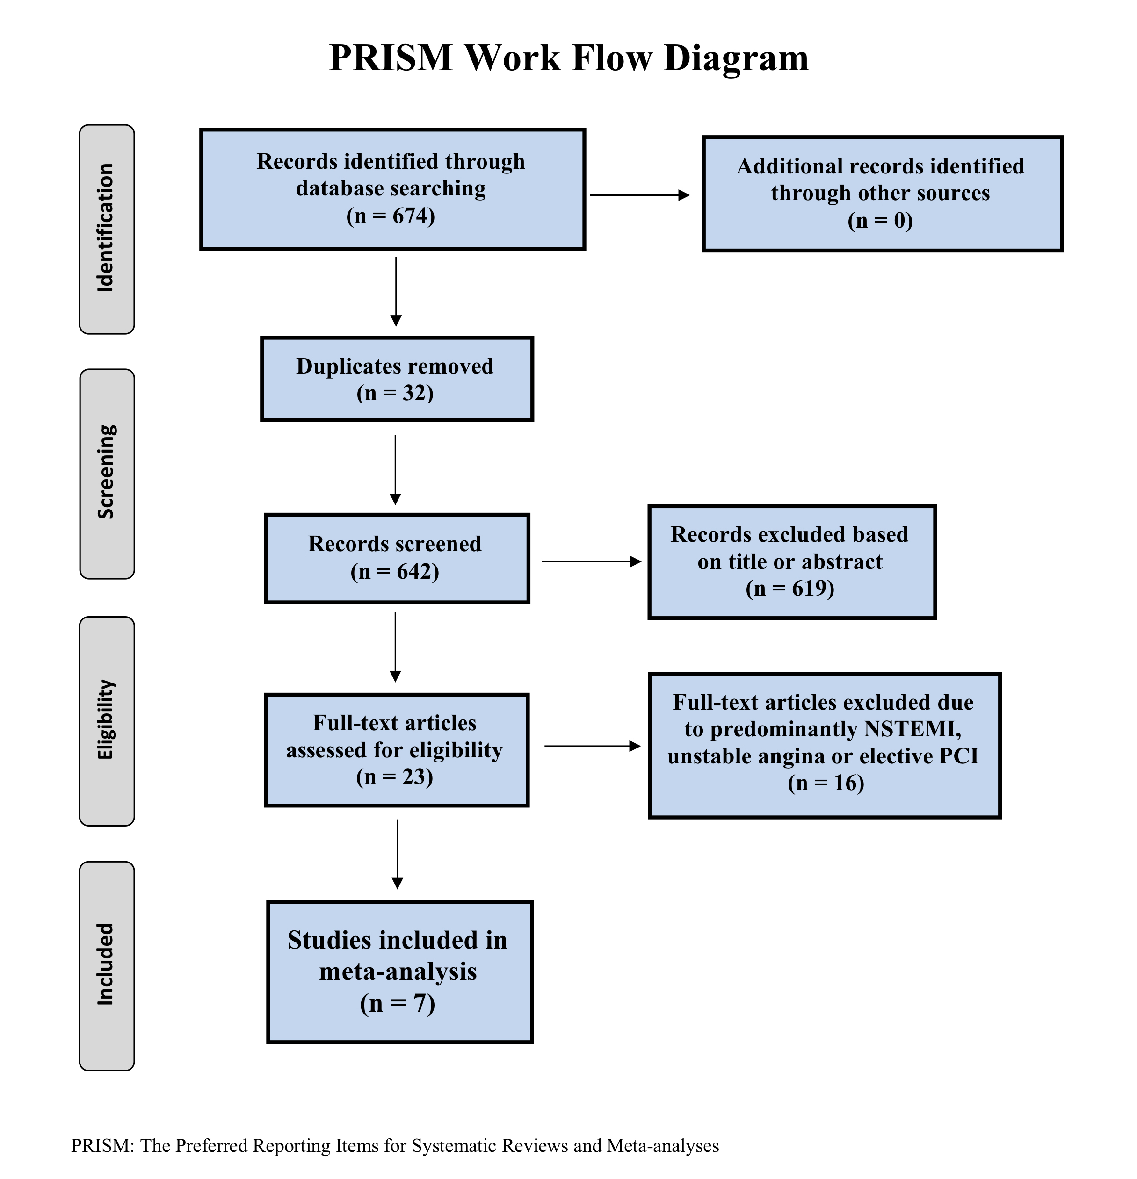
Table I. Trial Overview
Trials | Dates | Location | Sample size | Inclusion | Exclusion
HORIZONS-  AMI | March 2005 –  May 2007 | multi-center  multi-country | 3602 | >18y  *STEMI within 12h | prior use of thrombolytic or anticoagulant;  warfarin use; bleeding diathesis, coagulopathy,  †HIT, major bleed; ‡GI bleed in last 6m;  platelets <100; hemoglobin < 10  stroke in last 6m; coronary stent in last 30d;  §Cr Cl <30; life expectancy <1yr
EUROMAX | March 2010 –  June 2013 | multi-center  multi-country | 2218 | >18y  STEMI within 12h | prior oral anticoagulation use;  recent surgery; Cr Cl <30  history of bleeding
HEAT-PPCI | February 2012 –  Nov 2013 | one center  UK | 1829 | >18y  STEMI within 12hr | intolerance or allergy to any drug;  artificial ventilation;  altered mental status; Cr Cl <60
BRAVE-4 | Sept 2009 –  Dec 2013 | multi-center | 548 | >18yrs  STEMI within 24h | same as HORIZONS-AMI,  except Cr Cl <60
BRIGHT | Aug 2012 –  June 2013 | multi-center  China | 2194 | 18-80yrs  STEMI within 24h  or ||NSTEMI needing  emergent ¶PCI | cardiogenic shock; thrombolytic therapy;  anticoagulation in prior 48hr;  active or recent major bleed;  major surgery in last m.; #LFT 3X UL  aortic dissection, pericarditis;  **BP >180/110; Cr Cl <30  hemoglobin < 10, platelets <100
MATRIX | Oct 2011 –  Nov 2014 | multi-country  Spain  Sweden  Netherlands | 7213  STEMI: 401  NSTEMI: 3202 | STEMI within 12h or  24h for ongoing ischemia  or with fibrinolytics  NSTEMI with worsening or new ischemia  with two high risk factors: age >60yr,  elevated cardiac enzymes, ‡‡EKG changes | §§LMWH in last 6hr;  GPI use in last 3d  Cr Cl <30;  PCI in last 30d
VALIDATE-SWEDEHEART | June 2014 –  Sept 2016 | multi-center  Sweden | 6000  NSTEMI: 3001  STEMI: 3005 | patients with STEMI or  NSTEMI requiring urgent PCI | prior use of || ||GPI on admission;  Cr Cl <60; life expectancy <1yr  uncontrolled hypertension;  thrombocytopenia; ongoing bleed  subacute bacterial endocarditis
* STEMI: ST-elevation myocardial infarction
† HIT: heparin induced thrombocytopenia
‡ GI: gastrointestinal
§ Cr Cl: creatinine clearance
|| NSTEMI: Non-ST-elevation myocardial infarction
¶ PCI: percutaneous coronary intervention

# LFT: liver function tests
** BP: blood pressure
‡‡ EKG: electrocardiogram
§§ LMWH: low molecular weight heparin
|| || GPI: glycoprotein IIb/IIIa inhibitors

*Trial | Purpose | Bivalirudin | Control | Pre-Procedural
HORIZONS-  AMI | compared *Blvd to †UFH and  routine GPI in patients  undergoing emergent ‡PCI | 0.75mg/kg Blvd followed by  1.75mg/kg/hr until completion of ‡PCI only  §GPI for ||bailout | UFH 60u/kg  bolus for clotting time < 200-250sec  GPI in all patients | clopidogrel  UFH for both
EUROMAX | assessed Blvd versus UFH with optional use of GPI initiated during transport to emergent PCI; use of radial access and novel ADP inhibitors | 0.75mg/kg Blvd followed by  infusion of 1.75mg/kg/hr and  post-PCI ≥ 0.25mg/kg/hr for 4hr  GPI for bailout | UFH 100u/kg without GPI or  60u/kg with GPI or  IV bolus of enoxaparin 0.5mg/kg  GPI optional | novel P2Y₁₂  inhibitor
HEAT-PPCI | compared Blvd to UFH without use of GPI, unless necessary for bailout in patients undergoing emergent PCI | 0.75mg/kg Blvd followed by  1.75mg/kg/hr infusion during PCI  rebolus for clotting time <225s  GPI for bailout | UFH 70u/kg  bolus for clotting time <200s  GPI for bailout | novel P2Y₁₂  inhibitor
BRAVE-4 | compared use of Blvd with prasugrel versus UFH with clopidogrel in patients undergoing emergent PCI | prasugrel 60mg LD followed by 10mg with  Blvd 0.75mg/kg followed by  1.75mg/kg/hr during PCI  GPI for bailout | UFH 70-100u/kg  bolus for clotting time < 250s  GPI for bailout | UFH for both
BRIGHT | assessed Blvd in comparison to UFH alone or UFH plus tirofiban in patients undergoing emergent PCI | Blvd 0.75mg/kg followed by infusion of 1.75mg/kg/h for 30mins-4hr  and optional 0.2mg/kg/hr for up to 20hr  GPI for bailout | UFH 100u/kg bolus to achieve clotting time <225sec or UFH 60u/kg + tirofiban 10ug/kg followed by 0.15ug/kg/min for 18-36hr | clopidogrel
MATRIX | Comprised of 3 nested trials:  Access: Compared radial to femoral  Antithrombin: Compared to Blvd to UFH  Treatment Duration: post-PCI Blvd | 0.75mg/kg Blvd followed by infusion of 1.75mg/kg/hr until completion with subsequent randomization to continue infusion at full dose for 4hr or 0.25mg/kg/hr for 6hr  GPI for bailout | UFH 70-100u/kg without GPI  50-70u/kg with GPI  GPI optional | clopidogrel or  novel P2Y₁₂  inhibitor
VALIDATE-SWEDEHEART | assessed Blvd in comparison to UFH without use of routine GPI in patients undergoing emergent PCI | 0.75mg/kg Blvd followed by infusion of 1.75mg/kg/hr during PCI with 65% considered to received prolonged infusion (mean duration 57min)  GPI for bailout | UFH 70-100u/kg  bolus for clotting time <250s  GPI for bailout | novel P2Y₁₂  inhibitor  UFH for both
Table II. Trial Interventions
*Blvd: Bivalirudin
† UFH: Unfractionated heparin
‡ PCI: Percutaneous coronary angiography
§ GPI: Glycoprotein IIb/IIIa inhibitors
|| Bailout is defined as massive thrombus, heavy clot burden, slow or no reflow

*Trial names as previously outlined in manuscript

*Trial names as previously outlined in manuscript and table I
† Unfractionated heparin (UFH)
‡ Percutaneous coronary angiography (PCI)
§ Glycoprotein IIb/IIIa inhibitors (GPI)
|| Bailout is defined as massive thrombus, heavy clot burden, slow or no reflow

¹major bleeding defined as intracranial or intraocular hemorrhage; bleeding at access site, with a hematoma 5cm or larger that required intervention; decrease in hemoglobin (hgb)of 4 grams per deciliter (g/dL) or more without overt bleeding; 3g/dL with an overt bleeding source; reoperation for bleeding; or blood transfusion.
²Thrombolysis in Myocardial Infarction (TIMI)
³Global Utilization of Streptokinase and Tissue Plasminogen Activator for Occluded Coronary Arteries (GUSTO)
⁴NACE: combination of major bleeding or a composite of major adverse cardiovascular events, including death, reinfarction, target revascularization for ischemia, and stroke
⁵non-cardiac death includes bleeding-related death
⁶MACE: composite death from any cause, myocardial infarction, ischemia-driven revascularization, stroke
⁷This was the original primary outcome; it was changed during the course of the trial in order to obtain the necessary sample size for adequate power
⁸BARC: Bleeding Academic Research Consortium
⁹UFH: Unfractionated heparin; ¹⁰GPI: Glycoprotein IIb/IIIa inhibitors

¹STEMI: ST-segment elevation myocardial infarction
²NSTEMI: Non-ST-segment elevation myocardial infarction
³Cr Cl: creatinine clearance

Trial | Primary | Secondary | Bleeding | Outcomes (rates %)
HORIZONS-  AMI | major bleeding at 30d  *NACE at 30d | cardiac death  non-cardiac death  primary components  †MACE  NACE at 3yr | ‡HORIZONS  §TIMI  ||GUSTO | #Blvd alone compared to **UFH + ‡‡GPI reduced major bleed (4.9 v 8.3)  and NACE (9.2 v 12), sustained at 3yr  Blvd reduced cardiac death (1.8 to 2.9) and all cause death (2.1 v 3.1)  acute stent thrombosis was increased with Blvd (1.3 v 0.3)  MACE not statistically significant (5.5 v 5.4)
EUROMAX | NACE at 30d  major bleeding at 30d | composite of death  reinfarction or major bleeding  MACE and NACE at 30d  primary components | HORIZONS  TIMI  GUSTO | Blvd reduced NACE (5.1 v 8.5)  major bleeding (2.6 v 6.0) and MACE (6.6 v 9.2)  acute stent thrombosis was increased with Blvd (1.1 v 0.2)  no significant difference in rates of death (2.9 v 3.1)
HEAT-PPCI | MACE at 28d  major bleeding at 28d | stent thrombosis  troponins  BARC 2 minor bleeding | ¶BARC | MACE favors heparin: (8.7 v 5.7)  no difference in major bleed (3.5 v 3.1)  Blvd had more stent thrombosis (3.4 v 0.9)  no difference in all cause death (5.1 v 4.3)
BRAVE-4 | NACE at 30d | MACE  cardiac death  TIMI bleeding | HORIZONS | no difference in NACE (15.6 v 14.5) or MACE (4.8 v 5.5)  no difference in bleeding (4.1 v 12.0)  no difference in stent thrombosis with Blvd (1.1 v 1.5)
BRIGHT | NACE at 30d | MACE, NACE at 1yr  bleeding at 30 days and 1yr  stent thrombosis at 30d and 1yr  acquired thrombocytopenia at 30d  all cause death and cardiac death | BARC | Blvd reduced NACE at 30d (8.8 v 13.2 in UFH and  17.0 in UFH + tirofiban), which was sustained at 1yr  MACE insignificant among all groups (5.0, 5.8, 4.9)  bleeding at 30 days was reduced with Blvd (4.1, 7.5, 12.3)  no difference in acute stent thrombosis (0.6, 0.9, 0.7)
MATRIX | AT: MACE,  NACE at 30d  TD: composite  NACE at 30d | death from cardiovascular cause  stent thrombosis  TIMI and GUSTO bleeding | BARC | no major difference in MACE (10.3 v 10.9) or NACE (11.2 v 12.4)  Blvd reduced cardiac death (1.5 v 2.2) and all cause death (1.7 v 2.3)  Blvd had less major bleeding (11.0 v 13.6)  major bleeds reduced in radial group (2.1 v 2.9 at 1y)  overall stent thrombosis was marginally higher in Blvd (1.0 v 0.6)  without an increase in acute stent thrombosis (0.6 v 0.4)  prolonged infusion of Blvd did not decrease stent thrombosis
VALIDATE-SWEDEHEART | NACE at 180d | primary components  stent thrombosis | BARC | NACE did not differ at (7.2 v 8.0 at 30d and 12.3 v 12.8 180d)  all cause death insignificant (2.9 v 2.8 at 180d and 1.9 v 1.7 at 30d)  major bleeding insignificant (8.6 equally at 180d and 5.1 v 5.6 at 30d)  30d stent thrombosis favored Blvd (0.3 v 0.7)  but was insignificant at 180d (1.9 v 2.0)
Table III. Trial Outcomes
* NACE: combination of major bleeding or a composite of major adverse cardiovascular events, including death, reinfarction, target revascularization for ischemia, and stroke
† MACE: composite death from any cause, myocardial infarction, ischemia-driven revascularization, stroke
‡ major bleeding defined as intracranial or intraocular hemorrhage; bleeding at access site, with a hematoma 5cm or larger that required intervention; decrease in hemoglobin (hgb)of 4 grams per deciliter (g/dL) or more without overt bleeding; 3g/dL with an overt bleeding source; reoperation for bleeding; or blood transfusion.

§ TIMI: Thrombolysis in Myocardial Infarction
|| GUSTO: Global Utilization of Streptokinase and Tissue Plasminogen Activator for Occluded Coronary Arteries
¶ BARC: Bleeding Academic Research Consortium
# Blvd: Bivalirudin
**UFH: Unfractionated heparin
‡‡ GPI: Glycoprotein IIb/IIIa inhibitors

Table IV. Patient Comorbidities
*Trial names as previously outlined in manuscript
† Chronic Kidney Disease, defined as GFR <60

Table IV. Patient Comorbidities
* Chronic Kidney Disease, defined as GFR <60

Trial | Hypertension | Smoker | Prior Myocardial Infarction | Diabetes Mellitus | *Chronic Kidney  Disease
HORIZONS-  AMI | 42 – 45% | 45 – 47% | 10-11% | 15-17% | 16-17%
EUROMAX | 51 – 55% | 41 – 42% | 7-10% | 12-15% | 15-17%
HEAT-PPCI | 40 – 43% | 42 – 43% | 10-14% | 13-15% | 0%
BRAVE-4 | 64 – 66% | 57 – 67% | 21-30% | 45-41% | 0%
BRIGHT | 41 – 42% | 58 – 63% | 4.5% | 19-23% | 10-12%
MATRIX | 61 – 63% | 35 – 37% | 14-15% | 22-23% | 1-2%
VALIDATE-  SWEDEHEART | 52% | 24% | 16% | 16-17% | 0%

Trials | Study-Defined Outcome | Heparin |  |  |  | Bivalirudin |  |  |  | P-value
 |  | O | D | A | S | O | D | A | S | O | D | A | S
HORIZONS-  AMI | *Acute | 1.9 | 1.4 | 0.3 | 1.7 | 2.5 | 2.2 | 1.3 | 1.2 | NS | NS | 0.001 | NS
EUROMAX | †Definite  *Acute | X | 0.5 | 0.2 | 0.4 | X | 1.6 | 1.1 | 0.5 | X | 0.02 | 0.007 | NS
HEAT-PPCI | †Definite  *Acute | 0.9 | 0.7 | 0.9 | 0 | 3.4 | 3.3 | 2.9 | 2.9 | 0.01 | 0.01 | 0.007 | NS
BRAVE-4 | Overall | 1.5 | X | X | X | 1.1 | X | X | X | NS | X | X | NS
BRIGHT no GPI | Overall  *Acute | 0.9 | 0.7 | 0.3 | 0.6 | 0.6 | 0.4 | 0.3 | 0.3 | NS | NS | NS | NS
BRIGHT with GPI | Overall  *Acute | 0.7 | 0.6 | 0.3 | 0.4
MATRIX: Antithrombin | †Definite | X | 0.6 | 0.4 | X | X | 1.0 | 0.6 | X | X | 0.048 | 0.23 | X
MATRIX: TD  with infusion | †Definite | --- | --- | --- | --- | X | 1.3 | 0.6 | X | X | NS | NS | X
MATRIX: TD without infusion | †Definite | --- | --- | --- | --- | X | 0.7 | 0.6 | X | X | NS | NS | X
VALIDATE-  SWEDEHEART | †Definite at 180-d | 2.0 | 0.7 | X | X | 1.9 | 0.4 | X | X | X | NS | NS | X
 | ‡Subacute | 1.8 | 0.7 | X | X | 1.7 | 0.3 | X | X | X | NS | NS | X
Table V. Stent Thrombosis (Overall/Definite/Acute/Subacute)
*Acute: stent thrombosis that occurs within the first 24hr after PCI
† Definite: Overall stent thrombosis that is confirmed by angiography
‡ Subacute: stent thrombosis that occurs within 30d after PCI

Table VI. Reinfarction Rates
Trials | Heparin | Bivalirudin | P-value
HORIZONS-  AMI | 1.8 | 1.8 | *NS
EUROMAX | 0.9 | 1.7 | NS
HEAT-PPCI | 0.9 | 2.7 | 0.004
BRAVE-4 | 1.5 | 1.5 | NS
BRIGHT | 1.2  †0.8 | 1.0 | NS
VALIDATE-  SWEDEHEART | 1.1 | 0.8 | NS
MATRIX | 8.5  ‡8.6 | 8.6  ‡8.6 | NS
* NS: nonsignificant
† with glycoprotein IIb/IIIa inhibitors
‡ with extended bivalirudin infusion post-PCI

Table VII. Bleeding Events by Definition
Trials | sample size |  | Bleeding Definition | Heparin (n) | Bivalirudin (n) | P-value
 | Heparin | Blvd
HORIZONS-  AMI | 1802 | 1800 | Overall | 341 | 207 | <0.001
 |  |  | *HORIZONS | 149 | 89
 |  |  | †TIMI | 91 | 55
 |  |  | ‡GUSTO | 149 | 63
EUROMAX | 1109 | 1089 | Overall | 67 | 28 | <0.001
 |  |  | *HORIZONS | 18 | 0
 |  |  | †TIMI | 23 | 14
 |  |  | ‡GUSTO | 26 | 14
HEAT-PPCI | 907 | 905 | §BARC | 28 | 32 | || NS
BRAVE-4 | 275 | 269 | †TIMI | 8 | 7 | || NS
 |  |  | *HORIZONS | 33 | 38
BRIGHT | 1459 | 735 | §BARC 3-5 | 26 | 4 | || NS
MATRIX,  Antithrombin | 3603 | 3610 | §BARC 3-5 | 9 at 30d  116 at 1y | 55 at 30d  80 at 1y | || NS
VALIDATE-  SWEDEHEART | 3002 | 3004 | §BARC 3-5 | 56 at 30d  90 at 180d | 57 at 30d  100 at 180d | || NS
*HORIZONS: major bleeding defined as intracranial or intraocular hemorrhage; bleeding at access site, with a hematoma 5cm or larger that required intervention; decrease in hemoglobin (hgb)of 4 grams per deciliter (g/dL) or more without overt bleeding; 3g/dL with an overt bleeding source; reoperation for bleeding; or blood transfusion.
† TIMI: major ICH, drop in Hgb >5, fatal bleeding
‡ GUSTO: major or moderate: severe or life threatening, ICH, hemodynamic compromise, requiring blood transfusion
§ BARC: 3a: drop in Hgb 3-5, any transfusion; 3b: overt bleeding with hgb drop >5, hemodynamic compromise; 3c: intracranial hemorrhage; 5: probable or definite fatal bleeding
|| NS: nonsignificant

Figure I. Subgroup Analysis of Major Bleeding by Definition
