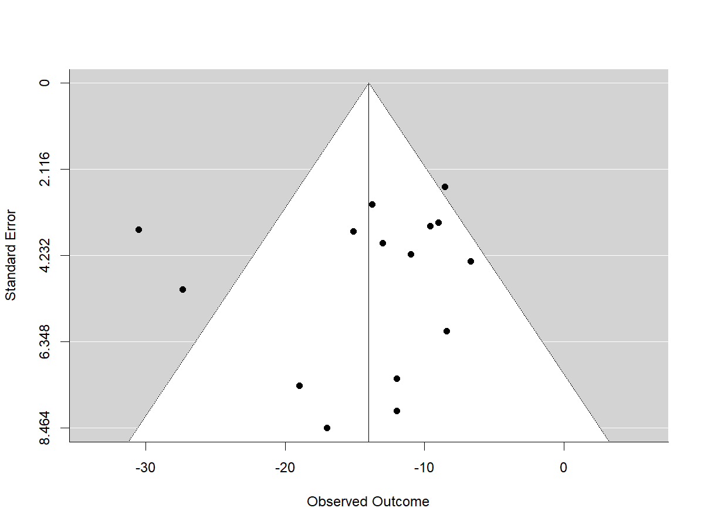
Supplementary Figure 1. Funnel plot of the 14 studies included in the meta-analysis.

